Be | K | Q3 | Q2 | Q1 | Q0 | Q3 n+1 | Q2 n+1 | Q1 n+1 | Q n+1 | Jd | Kd | Jc | Kc | Jb | Kb | Ja | Ka | D3 | D2 | D1 | D0
0 | 1 | 0 | 0 | 0 | 0 | 0 | 0 | 1 | 0 | 0 | X | 0 | X | 1 | X | 0 | X | 0 | 0 | 1 | 0
1 | 1 | 0 | 0 | 0 | 1 | 0 | 0 | 1 | 0 | 0 | X | 0 | X | 1 | X | X | 1 | 0 | 0 | 1 | 0
2 | 1 | 0 | 0 | 1 | 0 | 0 | 1 | 0 | 0 | 0 | X | 1 | X | X | 1 | 0 | X | 0 | 1 | 0 | 0
3 | 1 | 0 | 0 | 1 | 1 | 0 | 1 | 0 | 0 | 0 | X | 1 | X | X | 1 | X | 1 | 0 | 1 | 0 | 0
4 | 1 | 0 | 1 | 0 | 0 | 0 | 1 | 1 | 0 | 0 | X | X | 0 | 1 | X | 0 | X | 0 | 1 | 1 | 0
5 | 1 | 0 | 1 | 0 | 1 | 0 | 1 | 1 | 0 | 0 | X | X | 0 | 1 | X | X | 1 | 0 | 1 | 1 | 0
6 | 1 | 0 | 1 | 1 | 0 | 1 | 0 | 0 | 0 | 1 | X | X | 1 | X | 1 | 0 | X | 1 | 0 | 0 | 0
7 | 1 | 0 | 1 | 1 | 1 | 1 | 0 | 0 | 0 | 1 | 0 | X | 1 | X | 1 | X | 1 | 1 | 0 | 0 | 0
8 | 1 | 1 | 0 | 0 | 0 | 1 | 0 | 1 | 0 | X | 0 | 0 | X | 1 | X | 0 | X | 1 | 0 | 1 | 0
9 | 1 | 1 | 0 | 0 | 1 | 1 | 0 | 1 | 0 | X | 0 | 0 | X | 1 | X | X | 1 | 1 | 0 | 1 | 0
10 | 1 | 1 | 0 | 1 | 0 | 1 | 1 | 0 | 0 | X | 0 | 1 | X | X | 1 | 0 | X | 1 | 1 | 0 | 0
11 | 1 | 1 | 0 | 1 | 1 | 1 | 1 | 0 | 0 | X | 0 | 1 | X | X | 1 | X | 1 | 1 | 1 | 0 | 0
12 | 1 | 1 | 1 | 0 | 0 | 1 | 1 | 1 | 0 | X | 0 | X | 0 | 1 | X | 0 | X | 1 | 1 | 1 | 0
13 | 1 | 1 | 1 | 0 | 1 | 1 | 1 | 1 | 0 | X | 0 | X | 0 | 1 | X | X | 1 | 1 | 1 | 1 | 0
14 | 1 | 1 | 1 | 1 | 0 | 0 | 0 | 0 | 0 | X | 1 | X | 1 | X | 1 | 0 | X | 0 | 0 | 0 | 0
15 | 1 | 1 | 1 | 1 | 1 | 0 | 0 | 0 | 0 | X | 1 | X | 1 | X | 1 | X | 1 | 0 | 0 | 0 | 0
0 | 0 | 0 | 0 | 0 | 0 | 0 | 0 | 0 | 1 | 0 | X | 0 | X | 0 | X | 1 | X | 0 | 0 | 0 | 1
1 | 0 | 0 | 0 | 0 | 1 | 0 | 0 | 1 | 1 | 0 | X | 0 | X | 1 | X | X | 0 | 0 | 0 | 1 | 1
2 | 0 | 0 | 0 | 1 | 0 | 0 | 0 | 1 | 1 | 0 | X | 0 | X | X | 0 | 1 | X | 0 | 0 | 1 | 1
3 | 0 | 0 | 0 | 1 | 1 | 0 | 1 | 0 | 1 | 0 | X | 1 | X | X | 1 | X | 0 | 0 | 1 | 0 | 1
4 | 0 | 0 | 1 | 0 | 0 | 0 | 1 | 0 | 1 | 0 | X | X | 0 | 0 | X | 1 | X | 0 | 1 | 0 | 1
5 | 0 | 0 | 1 | 0 | 1 | 0 | 1 | 1 | 1 | 0 | X | X | 0 | 1 | X | X | 0 | 0 | 1 | 1 | 1
6 | 0 | 0 | 1 | 1 | 0 | 0 | 1 | 1 | 1 | 0 | X | X | 0 | X | 0 | 1 | X | 0 | 1 | 1 | 1
7 | 0 | 0 | 1 | 1 | 1 | 1 | 0 | 0 | 1 | 1 | X | X | 1 | X | 1 | X | 0 | 1 | 0 | 0 | 1
8 | 0 | 1 | 0 | 0 | 0 | 1 | 0 | 0 | 1 | X | 0 | 0 | X | 0 | X | 1 | X | 1 | 0 | 0 | 1
9 | 0 | 1 | 0 | 0 | 1 | 1 | 0 | 1 | 1 | X | 0 | 0 | X | 1 | X | X | 0 | 1 | 0 | 1 | 1
10 | 0 | 1 | 0 | 1 | 0 | 1 | 0 | 1 | 1 | X | 0 | 0 | X | X | 0 | 1 | X | 1 | 0 | 1 | 1
11 | 0 | 1 | 0 | 1 | 1 | 1 | 1 | 0 | 1 | X | 0 | 1 | X | X | 1 | X | 0 | 1 | 1 | 0 | 1
12 | 0 | 1 | 1 | 0 | 0 | 1 | 1 | 0 | 1 | X | 0 | X | 0 | 0 | X | 1 | X | 1 | 1 | 0 | 1
13 | 0 | 1 | 1 | 0 | 1 | 1 | 1 | 1 | 1 | X | 0 | X | 0 | 1 | X | X | 0 | 1 | 1 | 1 | 1
14 | 0 | 1 | 1 | 1 | 0 | 1 | 1 | 1 | 1 | X | 0 | X | 0 | X | 0 | 1 | X | 1 | 1 | 1 | 1
15 | 0 | 1 | 1 | 1 | 1 | 0 | 0 | 0 | 1 | X | 1 | X | 0 | X | 1 | X | 0 | 0 | 0 | 0 | 1

K=1 esetén:

$J_{d}$ $K_{d}$
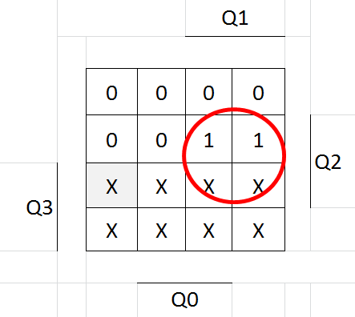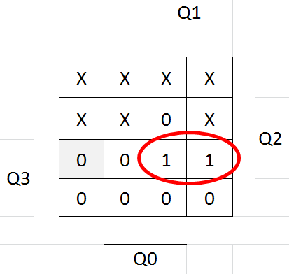

$J_{C}$ $K_{C}$

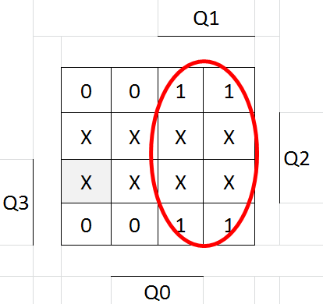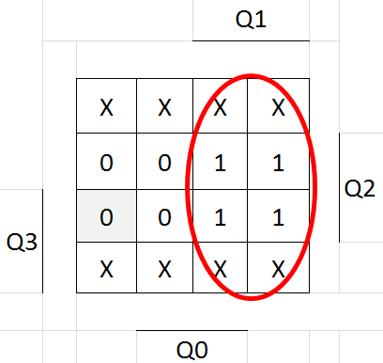

$J_{B}$ $K_{B}$

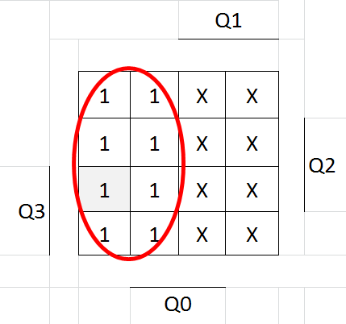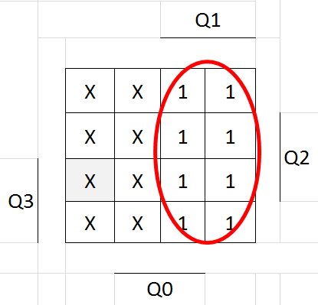

$J_{A}$ $K_{A}$

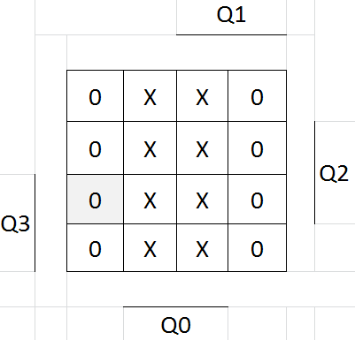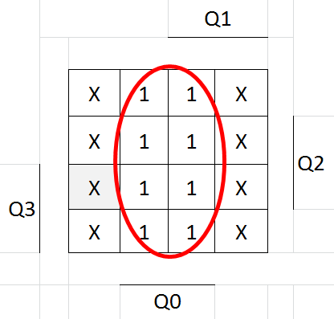

K=0 esetén:

$J_{d}$ $K_{d}$

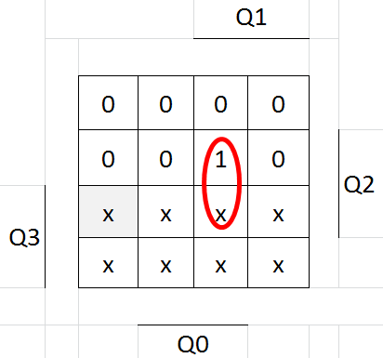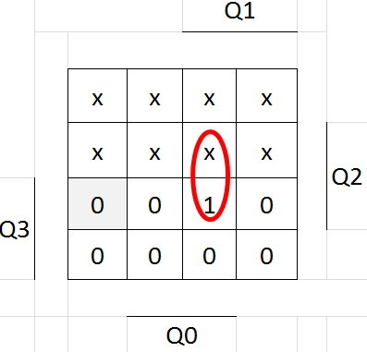

$J_{C}$ $K_{C}$

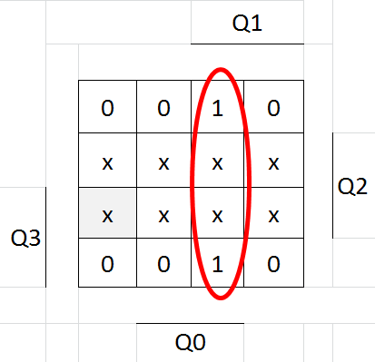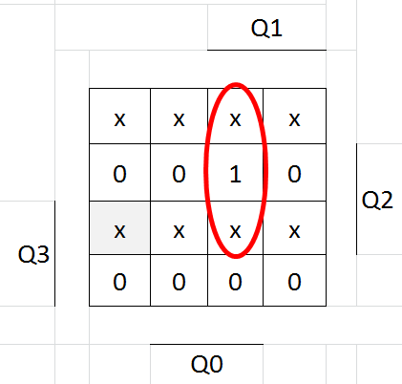

$J_{B}$ $K_{B}$

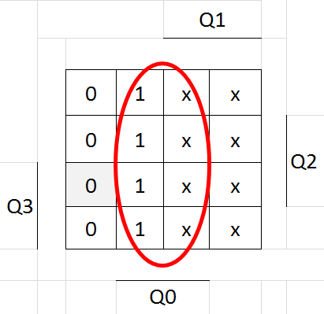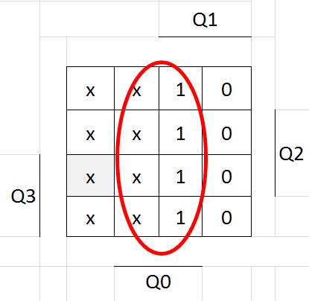

$J_{A}$ $K_{A}$

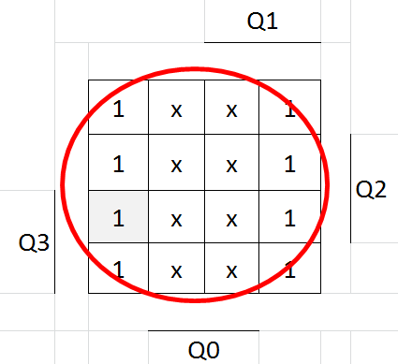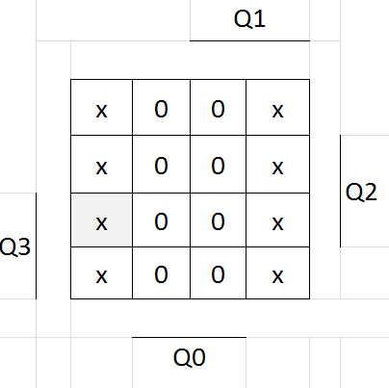

$$J_{D}=KQ_{1}Q_{2}+\overline{K}Q_{1}Q_{1}Q_{3}$$
$$K_{D}=KQ_{1}Q_{1}Q_{3}+\overline{K}Q_{1}Q_{2}Q_{3}$$
$$J_{C}=KQ_{1}+\overline{K}Q_{1}Q_{0}$$
$$K_{C}=KQ_{1}\overline{K}Q_{1}Q_{0}$$
$$J_{B}=K\overline{Q_{1}}+\overline{K}Q_{0}$$
$$J_{A}=\overline{K}$$
$$K_{A}=KQ_{0}$$

