Echo Sounders and Fish Finders
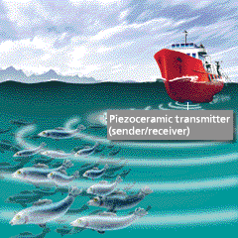
The applications for sonar systems range from single small transducers for pleasure craft to professional systems in large ships that detect water depth and schools of fish. Piezo-ceramic transmitters with varying geometries that cover a frequency range of 5 kHz to 10 MHz are used in the different systems. Some systems use the same piezo-ceramic transducers for transmitting and receiving. Others use different ceramic transducers for transmitting and receiving, such as in towed array sonar systems which can work over long distances. Large ships use transducer arrays, which consist of a high number of individual piezo-ceramic elements. These elements can be controlled separately and electronically delayed. This makes it possible to use electronic beam deflection.

Designs: Round disc, cylinder, rectangular plate, circular segment, spherical segment and other special designs
Materials: SONOX® P 4, SONOX® P 5, SONOX® P 8

Underwater Object Recognition (Sonar Technology)
The name “sonar” stands for “sound navigation and ranging”. What is meant are systems used for detection, locating and navigation under water. The applications for sonar systems range from single small transducers for pleasure craft for locating fish or obstacles to professional systems in large ships that detect water depth and schools of fish. Piezo-ceramic transmitters with varying geometries that cover a frequency range of 5 kHz to 10 MHz are used in the different systems. Some systems use the same piezo-ceramic transducers for transmitting and receiving. Others use different ceramic transducers for transmitting and receiving, such as in towed array sonar systems which can work over long distances. Large ships use transducer arrays, which consist of a high number of individual piezo-ceramic elements. These elements can be controlled separately and electronically delayed. This makes it possible to use electronic beam deflection.
Designs: Round disc, cylinder, rectangular plate, circular segment, spherical segment and other special designs
Materials: SONOX® P 4, SONOX® P 5, SONOX® P 8

