Description:
Drives up to 1 watt of LEDs per color. Perfect for a single 3 watt star RGB LED or up to 20 5mm RGB LED. Supports common anode or common cathode, changed via jumpers. The versitility of the driver supports a range of LED(s) and input voltage combinations.
Can be used for mood lamps, case mods, battery operated lanterns, display lights, and more.

Features:
- Drives up to 2 watt of LEDs per color.
- Dial and Pushbutton control of speed and functions.
- Auto fade w/ speed adjust via dial
-Manual color select via dial
-Dimming via dial
- Remembers user settings when turned on/off
- Pushbutton changes function, quick press changes between auto and manual, push and hold enables dimming
- Compatible with common anode, common cathode
or single color LED(s)

Parts shown are for Common Anode LED with 5 volt Input

Specification:

Full kit with 3 watt RGB LED
Board with Custom Resistors

Input Voltage
5v*
Input Voltage
5v-12v**

Input Current < 1 Amp
Input Current
< 1 Amp

Output Red
~350ma
Output Red
up to 2 watts

Output Green ~350ma
Output Green
up to 2 watts

Output Blue
~350ma
Output Blue
up to 2 watts

Connectors 0.1” Pitch
Connectors
0.1” Pitch

Dimension
1.5”x1.5“x0.5”
Dimension
1.5”x1.5“x0.5”

*5v available if the 7805 is not installed
**7-12 volts availible with simple modifications see Fig 4a & 4b
For Questions or Comments E-Mail to Support@ChromationSystems.com

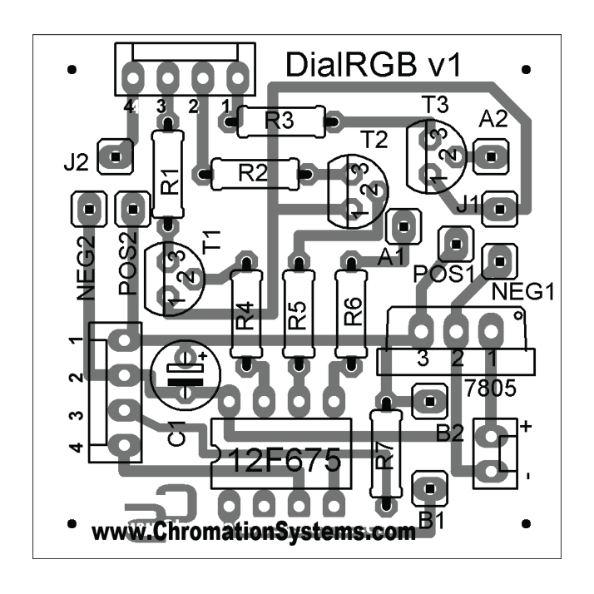Standard Layout
see Fig. 3c for Header Info
Header 1
- Blue LED
- Green LED
- Red LED
- Positive/Negative Header 2
- Positive, +5 v
- Negative, 0v
- Switch
- Potetiometer Center Tap R1 - 5.1 ohm, 1w
R2 - 16z ohm, 1w
R3 - 16 ohm, 1w R4 - 500 ohm, 1/4w R5 - 500 ohm, 1/4w R6 - 500 ohm, 1/4w R7 - 10kohm
T1 - Transistor, 2.5watt T2 - Transistor, 2.5watt T3 - Transistor, 2.5watt C1 - 0.1 uf disc capacitor Jumper B1 to B2 Jumper A1 to A2
Also:
2 Pin Header 8-Pin Socket
12F675 PIC Microcontroller
Header 1

Tools Required:
Header 2
- Soldering Iron
- Solder
- Needle Nose Pliars

Optional:
  - Volt Meter
  - Electrical Tape
  - Hot Glue Gun

For Common Cathode LED
J1 jumped to POS1 J2 jumped to NEG2
Header 1, pin 4 goes to LED cathode
T1-T3 are placed opposite of Top-Side outline
For Common Anode LED
J1 jumped to NEG1 J2 jumped to POS2
Header 1, pin 4 goes to LED anode T1-T3 are placed in as pictured

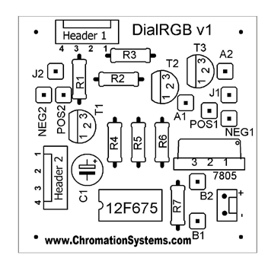Common Anode, 5 volt Input Common Cathode, 5 volt Input

Fig. 2a Fig. 2b

When using 5 volt as the input voltage, the 7805 is not used. So a jumper must be ran from Pin 1 to Pin 3, and the Solder pad for pin 2 needs to be filled in with solder. see Fig 2a & 2b

Pictured is the layout for the full kit with 3 watt RGB LED, with 5 volt input.

Fig. 3c
Header 1
- Blue LED
- Green LED
- Red LED
- LED Positive/Negative Header 2
- Positive, +5 v
- Negative, 0v
- Switch
- Potetiometer Center Tap

*careful not to plug the into the wrong header

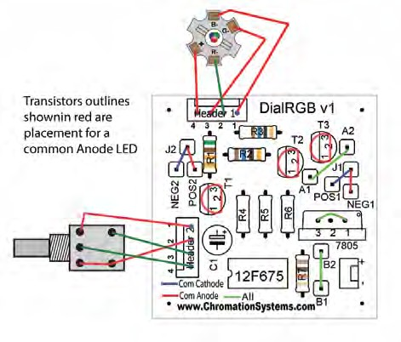

Fig. 3a Fig. 3b

*full size schematics availble on the website.

Common Anode, 7+ volt Input Common Cathode, 7+ volt Input

Fig. 4a Fig. 4b

