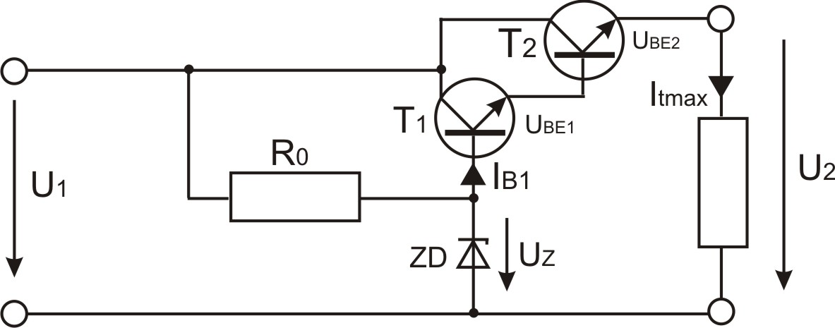

T1: (KF508) - BC639
h121Emin= 90
Ikmax= 1A
Uce= 80V
Pkmax= 800mW

T2: (KD333) - BD237
h221Emin=40
Ikmax= 2A
Uce= 80V
Pkmax= 25W

Itmax= 650mA
ΔU1= ±1,2V
R0= 140Ω
U1min= 15V
U2= 12V
Uke= 30,77V
U1max=42,77V
Ukemin= 3V
Uz= 13,6V
Izmin= 10mA (megválasztva)
Pzmin= 136mW
hd21e= h121Emin + h221Emin= 0,18mA
Ib1max= 180μA

