description
This is my electronic combination lock to use with an outdoor gate. The functionality is implemented in software. It turns on a relay (usually to open a door) for a few seconds if someone enters the valid code. This relay can operate a power-to-open type electric strike with a shorting contact or a power-to-hold type electromagnetic lock with a breaking contact (we need the relay because these locks usually work with AC, not DC). The code can be changed any time after entering the current code.
Current consumption of the circuit is low, because the PIC sleeps most of the time, and wakes up only for processing key presses. If you don't have a crystal, you can use the RC oscillator of the PIC16F84 as well, just check the PIC datasheets for details on oscillator configurations.
choices of lock versions:
v2-023: written for PIC16F84
v2-025: written for PIC16F628, optional LCD output
These versions share many features in common, the differences are detailed below.

operation
type in the correct code and use # as 'enter'. The initial code is 1234 after programming the un-modified HEX file. You could activate the output with typing in:
1 2 3 4 #
* is used to change the code. Type in the actual code then press *. If you didn't miss the actual code, the code change indicator LED will light up. Then type in the new code twice. Eg:
1 2 3 4 * 1 9 9 8 # 1 9 9 8 #
will change the code to 1998. The code changes immediately and permanently after typing the new code twice. If you miss entering the new code twice, the original code is kept.

software
Essentially, all software versions work the same. You can download and customize the source code for the version you choose. The first few lines of the code contain definitions of changeable parameters. If you are lazy, you can simply download the HEX files already compiled with default values. The definitions:
mhz EQU D'4' | this value is used for delay calibration. Of course, the code will run with different speed hardware as well, but faster or slower than intended.
pulsewidth EQU 'D'150' | this value is used to set the delay of the output pulse. To calculate the delay in seconds, use pulsewidth * 20 ms
clen EQU 4 | this value sets the length of the code. The length is always fixed, and you can set it much higher, until you have available RAM on the chip
More details on the source code can be found here.

hardware
The keypad is actually a collection of push-buttons, organized into a matrix. It looks like this:
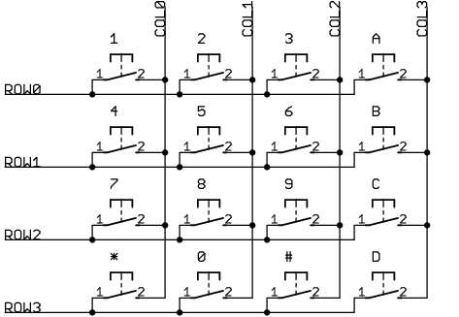 | COL0 | COL1 | COL2 | COL3
ROW0 | 1 | 2 | 3 | A
ROW1 | 4 | 5 | 6 | B
ROW2 | 7 | 8 | 9 | C
ROW3 | * | 0 | # | D
If you have a different layout keypad, you can change the definition of the buttons (keytable) in the source code. The keytable contains four lines, each consisting of four characters:
dt "123a"
dt "456b"
dt "789c"
dt "*0#d"
You can use a 3x4 keypad or a 4x4 keypad. The advantage of the bigger keypad is that you can use the extra letters in codes. Connect the keypad wires to the lock by the labels (ROW0 to ROW0, COL0 to COL0, and so on). In case of using a 3x4 keypad, simply leave the COL3 input unconnected, no other modification is required. If you don't have a keypad, you can even wire one from push-buttons.
Use a power source with DC output between 8 and 30 volts, min 200 mA (or higher, depending on your relay current) to power the lock.
The relay specifications are not given here, because you can choose from many. Choose the relay voltage based on your incoming voltage. If you use 12VDC to power your lock, choose a 12V DC relay. Choose the relay switch ratings based on what you intend to switch with it. For an electric strike, use one capable of switching at least 2A/24V.
The component labeled 'BUZZER' is a passive ceramic piezo sounder. Do not use buzzers with internal (sound generator) electronics and/or with low-impedance speaker coils in it.

power-up for the first time
- before putting the programmed PIC into the working circuit, test that connecting the resistor on pin#8 to VDD operates the relay
- while the relay is on (see previous instruction), check that VDD on pin#14 is +5VDC
- putting in the programmed PIC, you should hear a beep at power-up. If you hear nothing, the program is not running in the PIC. Check the crystal and verify the programming of the PIC.
- pressing keys on the keypad should generate one beep per press. If you hear nothing, check the contacts with an ohmmeter: put the leads to one row and a column. Pressing the key in the crossing should give a low (resistance lower than 1 kilo-ohms) resistance on the meter. Untouched, every row-column combination should give no contact (resistance higher than 100 kilo-ohms)
- pressing keys on the keypad should generate one beep per press. If you hear more than one beeps, you need to adjust the running frequency of the program. Try decreasing the mhz definition or add more delays into the read loop
If you are stuck with a problem, please check the FAQ first.

FAQ
Q: I don't want anyone to change the code. What should I do?
A: replace the '*' key in the keytable to '#'.
A: place the 3rd column of your keypad inside the box containing the PCB and change the keytable so as only the 3rd column contains the key '*'
Q: I lost the code for the lock. What should I do?
A: Re-program the PIC chip with the latest HEX file you used. The code will be reset to the value in the HEX file
A: read out the contents of the PIC with a programmer. You can find the actual code stored in the DATA EEPROM. Depending on the programmer software, the code can be modified and written back as well
Q: Is there a way to make this design work as an on/off switch (toggle) instead of a momentary switch? In detail, enter code to turn a switch on, enter the code again to turn the switch off
A: yes. The modified PIC16F84 code is downloadable here, name cl2b.asm
Q: The combination lock seems to work (it beeps once for every keypress), but it doesn't operate the relay!
A1: There can be a problem with operating your relay. To check, disconnect resistor from pin#8 (RB2) and touch it to the VDD (pin#14). If it does not operate the relay, check your transistor and the diode polarity. Measure the output of pin#8 (RB2) when you entered the correct code. It should change to +5VDC for the preset time interval then back to 0VDC
A2: you possibly misconnected some row/column lines so incorrect keycodes are generated. Eg, if you swap col0 and col1 wires, and press the keys 1 2 3 4, it gets interpreted as 2 1 3 5
Q: I don't have a 22pF capacitor. Can I use another value?
A: yes, any value between 10-25pF should work

combination lock v2-023 for PIC16F84

schematic
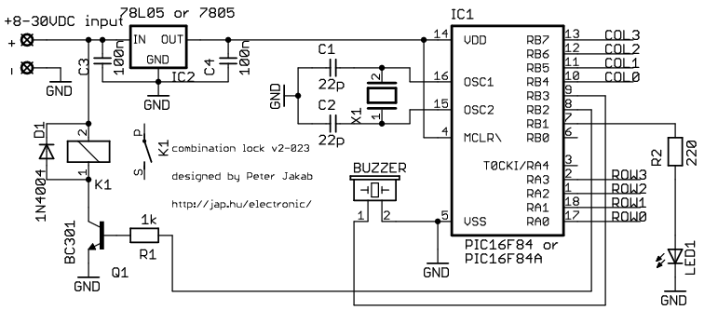

code
description | written by | download
source code and HEX file with default settings (10 MHz) | Peter JAKAB | cl2.asm  cl2.hex
HEX file with default settings for 4MHz | Peter JAKAB | cl2-04.hex
details of the source code internals | Peter JAKAB | combination_lock-alg.txt
experimental source and HEX file modified for toggle (ON/OFF) relay operation | Peter JAKAB | cl2b.asm  cl2b.hex
experimental source modified to accept 8 different 6-digit codes | Alan Carvalho de Assis | cl2c.asm
experimental source and HEX file modified to accept two different 6-digit codes for activating two pulse outputs  the second output is RB0 | Melvic S. Punzalan | cl2d.asm  cl2d.hex

part list
part number | description
IC1 | PIC16F84-10 or  PIC16F84A - Microchip microcontroller, pre-programmed
IC2 | 78L05 or  7805 - 5V output voltage regulator
Q1 | BC301 or similar npn bipolar transistor, Ic(min)=500 mA
D1 | 1N4001, 1N4004 or 1N4007 diode
LED1 | any color LED or  3mm green LED
R1 | 1 kohm 1/4W resistor
R2 | 220 ohm 1/4W resistor
C1 | 22 pF ceramic capacitor
C2 | 22 pF ceramic capacitor
C3 | 100 nF ceramic capacitor
C4 | 100 nF ceramic capacitor
X1 | 10MHz or 4MHz crystal
BUZZER | ceramic piezo sounder  (also called 'piezo diaphragm', 'piezo audio transducer', 'piezo audio indicator')
keypad | 3x4 or 4x4 matrix keypad
K1 | relay, see text for specifications
misc | power supply with 8-30V DC output - suggested voltage is 12VDC  connectors for the power supply and the keypad  Printed Circuit Board (PCB), strip board or bread-board  flexible wires for connecting relay, LED, buzzer, power supply, keypad  housing for the electronics

PCB
Please note that the component numbering and connector pin-out on the PCB won't match the schematic!
PCB name | Postscript | PDF
standard PCB | copper  stuffing | copper  stuffing
PCB with power supply | copper  stuffing | copper  stuffing

combination lock v2-025 for PIC16F628 with optional LCD
Newer version of the combination lock, adapted to the PIC16F628. You can connect an optional 2x16 character LCD to this circuit.

software
In addition to the standard definitions, you may want to change these variables:
#define HIDDEN_CODE '*' | this is the definition of what you see on the LCD instead of the digits (default is asterisk). If you delete this line, the digits are shown as entered
msg_line EQU 0x80 | this value contains the LCD position for messages. By default it contains the address of the first LCD line (documented in the LCD datasheet)
code_line EQU 0xc0 | this value contains the LCD position for code entry. By default it contains the address of the second LCD line (documented in the LCD datasheet)

schematic
This is the main schematic, not showing the optional serial LCD interface, which connects to the 6-pin connector 'serial LCD'.
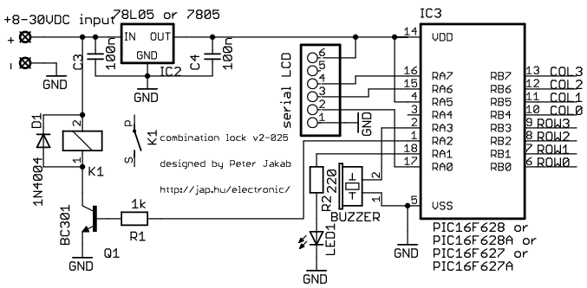

code
description | written by | download
source code and HEX file with default settings | Peter JAKAB | cl2-025.zip  cl2-025.hex
HEX file, show entered digits in clear | Peter JAKAB | cl2-025b.hex

part list
The parts for the LCD interface are not included in this list.
part number | description
IC1 | PIC16F627 or  PIC16F628 or  PIC16F627A or  PIC16F628A - Microchip microcontroller, pre-programmed
IC2 | 78L05 or  7805 - 5V output voltage regulator
Q1 | BC301 or similar npn bipolar transistor, Ic(min)=500 mA
D1 | 1N4001, 1N4004 or 1N4007 diode
LED1 | any color LED or  3mm green LED
R1 | 1 kohm 1/4W resistor
R2 | 220 ohm 1/4W resistor
C3 | 100 nF ceramic capacitor
C4 | 100 nF ceramic capacitor
BUZZER | ceramic piezo sounder  (also called 'piezo diaphragm', 'piezo audio transducer', 'piezo audio indicator')
keypad | 3x4 or 4x4 matrix keypad
K1 | relay, see text for specifications
lcdif | serial LCD interface: an HD44780-compatibe 2x16 char LCD and some more electronics  optional, see text
lcdconn | 6-pin header for connecting the LCD interface
misc | power supply with 8-30V DC output - suggested voltage is 12VDC  connectors for the power supply and the keypad  Printed Circuit Board (PCB), strip board or bread-board  flexible wires for connecting relay, LED, buzzer, power supply, keypad  housing for the electronics

3-wire serial LCD interface for the PIC
version 2
based on the idea of Myke Predko

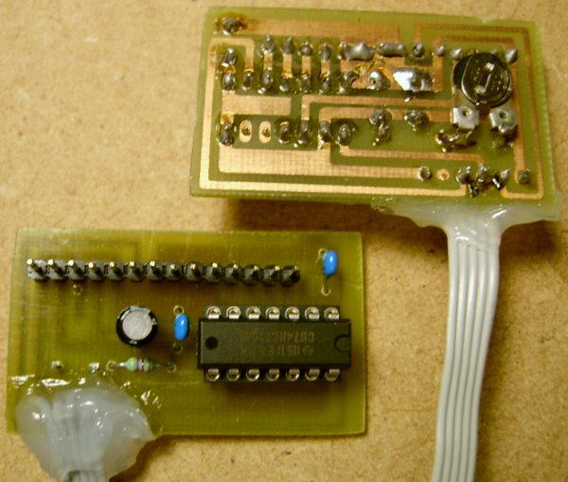

description
If you are developing applications for the PIC, and miss the costly debugging tools, or can't afford a parallel LCD interface in your design, this serial interface can help printing debug messages and/or reduce the pin count. This version uses a Hitachi HD44780 compatible LCD module in 4-bit mode. The interface is based on the idea of Myke Predko. See this link for more details.

software
My default PIC pins for the interface connection are RB4 (EN), RB5 (CK), RB6 (DA). I choose these pins due to PCB layout simplicity on the 18 pin devices. It is the task of your application to correctly initialize the TRIS bits of the used port pins!
LCD library (001) source for the PIC16F84 | lcdlib.asm
LCD library header file for linked projects | lcdlib.inc
example program | lcdtest.asm
HD44780 LCD controller datasheet | hd44780.pdf

schematic diagram
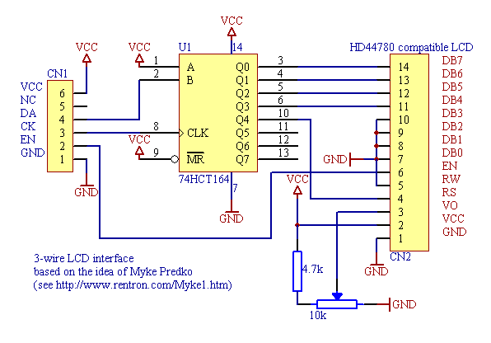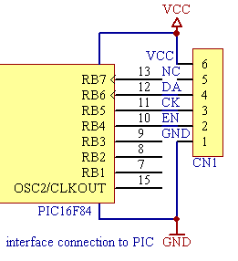
Warning: include(../phpbb/vf.php) [function.include]: failed to open stream: No such file or directory in /var/www/jap.hu/electronic/lcdif.html on line 69

