The procedure is this:
-Place all the VDS files in a folder on the disk (there is enought space for VDS and Dos 6.22 on one disk. VDS does not need high memory)
-Boot the comptuer into real mode dos (win 9x command prompt only. dos 6.22, etc)
-Run the vag.bat file in the VDS folder
-Press ESC to cancel the autoconnect
-Connect your cable (it should not be connected before this)
-Connect to the CCM (enter 46)
-Login with code 19283 (function 11)
-Look up and write down your existing memory values (function 26)
-Change the values (function 27)
-Close the connection (function 06)
-Test that things work as they should!
The 'main' screen in VDS:
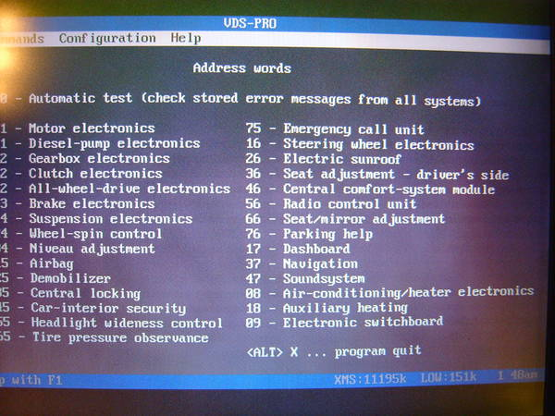
Making a session with the CCM:
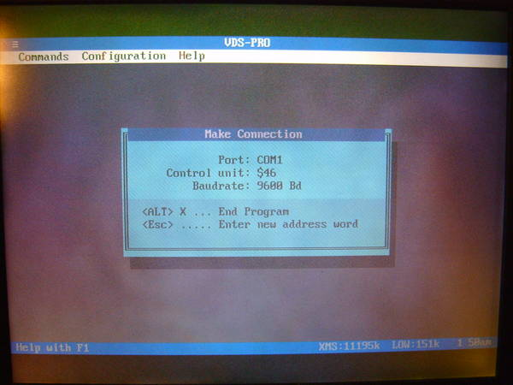
CCM is open. Note the PN at the bottom of the screen. My 99.5 has the 1J0 959 799 AJ controller.
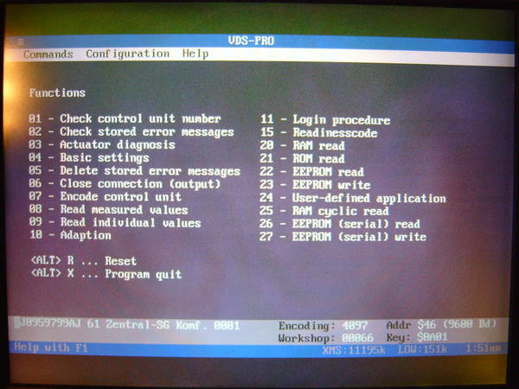
Logging in:
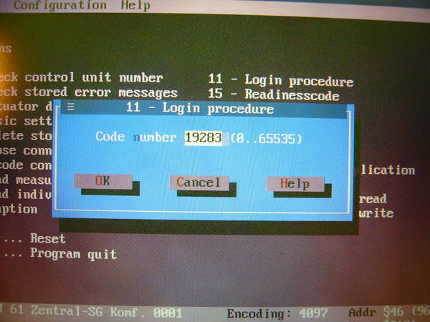
Reading the current memory blocks. You must do this for each location and write down what data is currently present, in case you screw up like I did initially and need to go back.
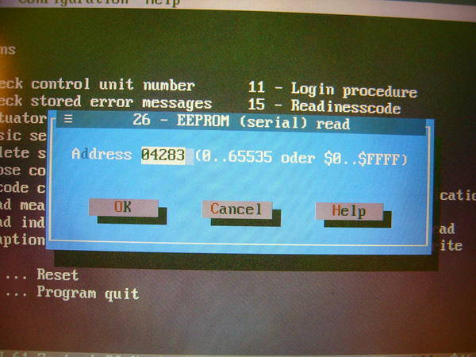
Location 0 is what will be changed:
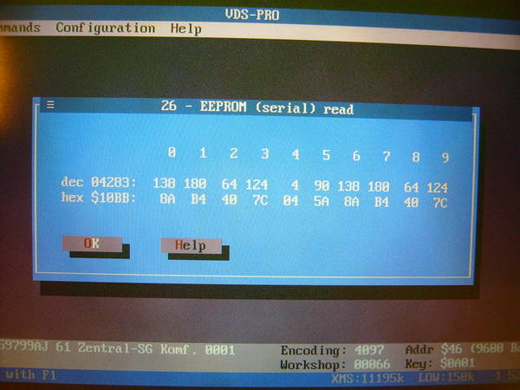
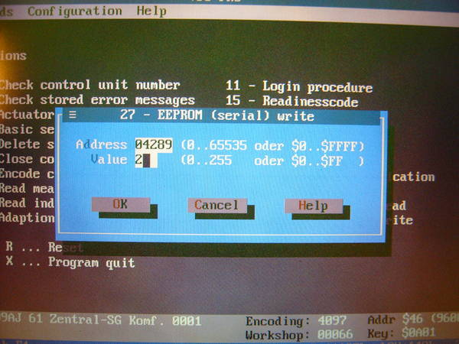
Confirmation window:
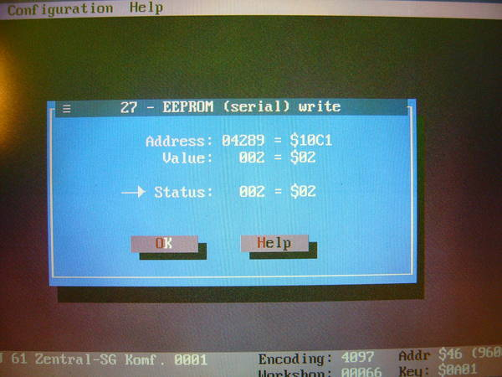
Once again, I would like to stress the importance of writing down the original values, in case you mess up. Also, if the 'old' or 'original' numbers listed in this thread don't match what's in your CCM, you can still do this. What is important is the difference between the 'old' and 'new' value.
For example, in every 1C0 CCM I've done this with it was simply a matter of subtracting 8 from the values at 04361-04363. If I recall correctly, some of the values in my 99.5 were different, and again the important thing is the difference beween the 'old' and 'new' value. The exception are the first 2 addresses in the 1J0 CCMs, which get set to 2. But even if it doesn't work, you can always go back because you wrote down the original value, right
I will not post a link to the VDS software as it's illegal. But, I will post a link to the config file... if you Google for vds-pro, the version that you can download does not have the right config file to enable DMA.
http://compu85.homeip.net/vds/VD_config.zip
Username: tdi
Password: idt

1J0 959 799 AH (any index) and 1J0 959 799 S 03B
Code:
Memory Address / old value / new value
04283 / 8 / 2
04289 / 8 / 2
08628 / 242 / 246 driver side front window
12724 / 250 / 254 passenger side front window
16820 / 250 / 254 driver side rear window
20916 / 242 / 246 passenger side rear window
1J0 959 799 J 00E
Code:
Memory Address / old value / new value
04286 / 8 / 2
04291 / 8 / 2
04296 / 8 / 2
08628 / 242 / 246 driver side front window
12724 / 250 / 254 passenger side front window
16820 / 250 / 254 driver side rear window
20916 / 242 / 246 passenger side rear window
1C0 959 799 A (any index) and 1C0 959 799 B (any index) for Variant/Wagon
Code:
Memory Address / old value / new value
04361 / 75 / 67
04362 / 75 / 67
04363 / 75 / 67
1C0 959 799 A (any index) and 1C0 959 799 B (any index) for Limousine/Sedan
Code:
Memory Address / old value / new value
04361 / 74 / 66
04362 / 74 / 66
04363 / 74 / 66
1J0 959 799 S 03B
Memory Address old value new value
04283 8 2
04289 8 2
08628 242 246 driver side front window
12724 250 254 passenger side front window
16820 250 254 driver side rear window
20916 242 246 passenger side rear window
1J0 959 799 J 00E
Memory Address old value new value
04286 8 2
04291 8 2
04296 8 2
08628 242 246 driver side front window
12724 250 254 passenger side front window
16820 250 254 driver side rear window
20916 242 246 passenger side rear window
1J0 959 799 AH 046 Sedan
Memory Address old value new value
04295*** 138/ 64
04283 138 / 64
04289 138 / 2
08628 242 / 246
12724 250 / 254
16820 242 / 246
20916 250 / 254
1J0 959 799 AH 06Q Sedan
Memory Address old value new value
04295*** 72 / 64
04283 72 / 64
04289 72 / 2
08628 242 / 244
12724 250 / 252
16820 242 / 244
20916 250 / 252
***This memory address added to keep the rear trunk handle from locking the car
1C0 959 799 A (any index) and 1C0 959 799 B (any index) for Wagon
Memory Address old value new value
04361 75 67
04362 75 67
04363 75 67
1C0 959 799 A (any index) and 1C0 959 799 B (any index) for Sedan
Memory Address old value new value
04361 74 66
04362 74 66
04363 74 66
1C0 959 799 C (2002 Golf)
Memory Address old value new value
04361 138 66
04362 138 66
04363 138 66
1C0 959 799 C (2004 Golf GLS TDI)
Memory Address old value new value
04361 138 130
04362 138 130
04363 138 n/c
1C0 959 799 F or 1C0 959 799 G
Memory Address old value new value
04361 202 194
04362 202 194
04363 202 194
1J0 959 799AJ
Memory Address old value new value
04283 138 2
04289 138 2
08628 242 246 driver side front window
12724 250 254 passenger side front window
16820 242 246 driver side rear window
20916 250 254 passenger side rear window
1J0 959 799 S 03B
Memory Address old value new value
04283 8 2
04289 8 2
08628 242 246 driver side front window
12724 250 254 passenger side front window
16820 250 254 driver side rear window
20916 242 246 passenger side rear window
1J0 959 799 J 00E
Memory Address old value new value
04286 8 2
04291 8 2
04296 8 2
08628 242 246 driver side front window
12724 250 254 passenger side front window
16820 250 254 driver side rear window
20916 242 246 passenger side rear window
1C0 959 799 A (Wagon)
Memory Address old value new value
04361 75 67
04362 75 67
04363 75 67
1C0 959 799 B (Wagon)
Memory Address old value new value
04361 75 67
04362 75 67
04363 75 67
1C0 959 799 B (Wagon)
Memory Address old value new value
04361 74 66
04362 74 66
04363 74 66
1C0 959 799 B (Sedan)
Memory Address old value new value
04361 74 66
04362 74 66
04363 74 66
1C0 959 799 C (Wagon)
Memory Address old value new value
04361 203 195
04362 203 195
04363 203 195
1C0 959 799 C (Sedan)
Memory Address old value new value
04361 202 194
04362 202 194
04363 202 194
1J0 959 799AJ
Memory Address / old value / new value
04283 / 138 / 2
04289 / 138 / 2
08628 / 242 / 246 driver side front window
12724 / 250 / 254 passenger side front window
1C0 959 799 F
Memory Address / old value / new value
04361 / 202 / 194
04362 / 202 / 194
04363 / 202 / 194
1C0 959 799 G
Memory Address / old value / new value
04361 / 202 / 194
04362 / 202 / 194
04363 / 202 / 194

1J0 959 799AJ
Memory Address old value new value
04283 138 2
04289 138 2
08628 242 246 driver side front window
12724 250 254 passenger side front window

1C0 959 799 C (2003 Jetta Wagon TDI)
Memory Address old value new value
04361 202 194
04362 202 194
04363 202 194

6N0 959 799 B 07F
Memory Address old value new value
04283 10 2
04289 10 2
4295 10 2

