USB Data acquisition with PIC18F4550
This project is simple and small component count USB data acquisition or USB DAQ. The main core of USB device is PIC18F4550 .The
firmware for PIC modified from Microchip CDC library.
I use Delphi 6 on PC side to communicate with PIC18F4550
source code availible.
Specifications
- 8 Digital output
- 8 Digital input
- 8 Analog output
- No external power required
- Simple ASCII command
- 3 command to communicate PC with PIC
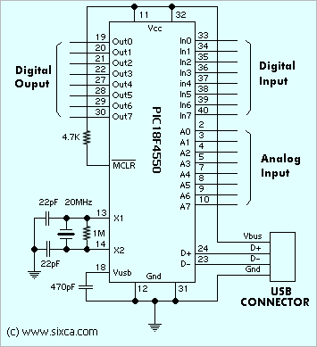
Figure 1 Schematic
Command
CommandPC Send PIC respone
Write digital output *ANS#13-
Read digital input *B#13*BHH#13
Read analog input*AK#13*AKXXXX#13
When :
N = bit that we need to set or clear (0-7)
S = state of bit (0-1)
HH = Input status from digital input port (00-FF)
K = Channel of analog input ( 0-7)
XXXX = analog input value in decimal of 10 bit binary (0000-1023 )
#13 = end of command
Example to set bit 0 of digital output
*A01#13
Example to clear bit 0 of digital output
*A00#13
Example to read digital input
*B#13
then PIC respone with
*B7F#13
This mean bit 7 of digital input was low
Example to read analog input channel 4
*C4#13
then PIC respone with
*C41023#13
This mean that analog channel 4 have 5 volt on this channel
becuase 1023 = 3FFh
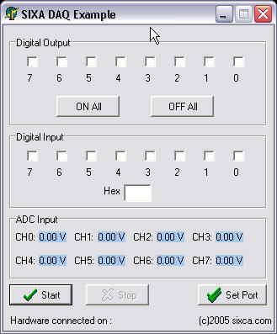
Figure 2 PC side software

When connect this USB Data acquisition with PC then windows ask for driver after driver installed(only first time) you will have a new COMx if not connect the COMx not create by Windows.
How to set configuration read this article
Download source code
Firmware C18 Compiler , Delphi 6 example,Windows device driver (Win2K/XP)
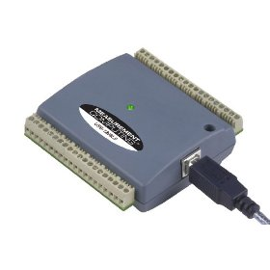
USB Data Acquisition Module
Relate articles
USB CDC example
Control stepping motor with USB

Copyright(c) 2005-2009 sixca.com, All rights reserved.
Best view @ 800X600, IE 6.0 up Terms of Use Priv

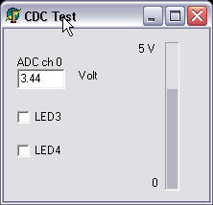
USB Interface Microchip PIC18F4550 with CDC library
This example demonstration how to use USB PIC18F4550 with CDC library .I modified this from CDC example for PICDEM FS USB. I use Delphi to control PIC18F4558 via USB.To use Delphi example you must download TComPort component for delphi(in this site)
In delphi I want to control LED3 , LED4 and Read ADC Port0(RA0) then show in volt format and progressbar.
If you have PICDEM FS USB board you can use this example. But, if you don't have you can use my schematic I was designed for my test
To program PIC18F4550 chip you must set configuration bit
in PIC programmer software follow Pictire 2

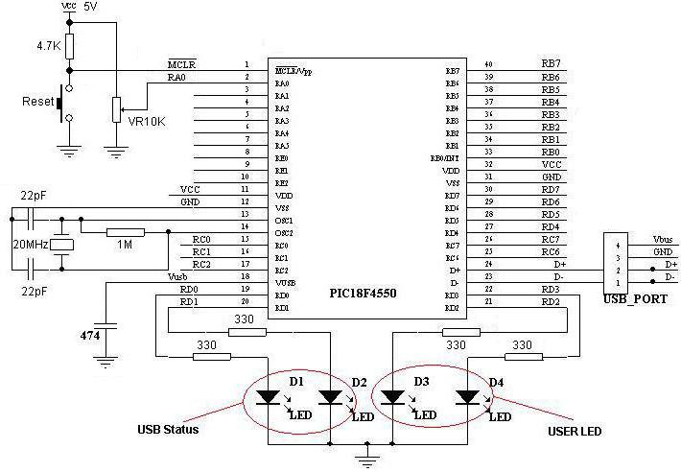
Picture 1 Schematic for my test
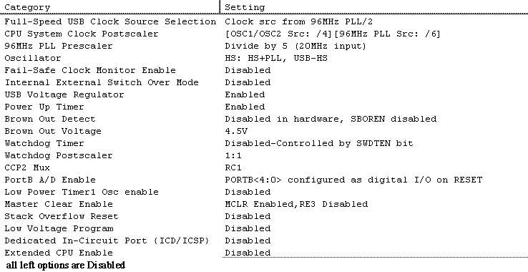
Picture 2 Configulation bit for this article

Note : I change some thing from orginal CDC library in file by add comment on line in autofiles\usbcfg.h
//#define USE_SELF_POWER_SENSE_IO
//#define USE_USB_BUS_SENSE_IO
Example consist of :
- CDC Examples I was modified from orginal compile with C18
- Delphi 6 example
- Driver WinXP/2K(original)
Source code
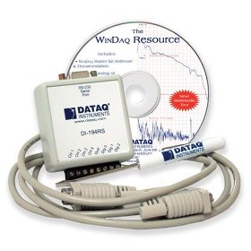
Data Acquisition Starter Kit
Relate articles
Control stepping motor via USB with PIC18F4550
USB data acquisition with PIC18F4550

